Improper Session Invalidation – Reuse of Session Cookie After Logout
Severity | High
CWE | CWE-613 – Insufficient Session Expiration
OWASP Top 10 | A07 – Identification and Authentication Failures
Related Category | A01 – Broken Access Control (related impact only)

Summary
The application does not properly invalidate a user's authenticated session after logout.
During testing, User 1 successfully authenticated and a valid session cookie was captured. User 1 was then logged out. After subsequently logging in as User 2, the previously captured User 1 session cookie was replayed in place of User 2's cookie.
The application continued to accept the old User 1 session cookie and returned User 1's authenticated data.
This demonstrates that a previously issued session remains usable after logout, allowing an individual who possesses the session cookie to continue accessing the associated user's resources.

Impact
An attacker who obtains a valid user's session cookie may be able to continue accessing the victim's account even after the victim has logged out.
Potential impact includes unauthorized access to:
- User profile information
- User ID and username
- Bills and billing information
- Other authenticated API resources
- Other sensitive information associated with the victim's account
This may result in unauthorized disclosure of user data and session hijacking/replay.

Proof of Concept / Steps to Reproduce
Step 1: Login as User 1
Log in to the application using valid credentials for User 1.
Capture the authenticated request in Burp Suite and note the session cookie issued by the application.
Screenshot 1 – User 1 session
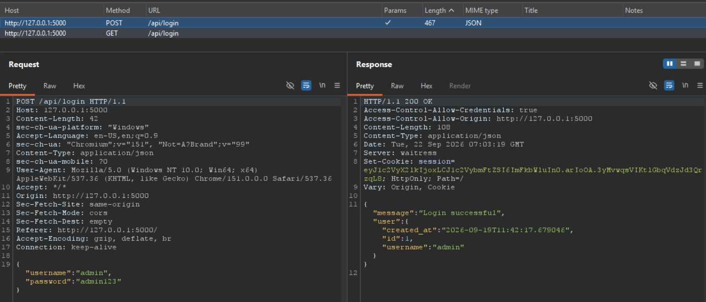
The response confirms successful authentication as User 1 and provides the authenticated session cookie.
User 1
Username: admin
Session Cookie: <USER_1_SESSION_COOKIE_REDACTED>

Step 2: Logout User 1
Log out from the User 1 account. After logout, the previously issued User 1 session should no longer be accepted by the server.
Logout response observed: successful logout.
Expected behavior: subsequent requests using the invalidated User 1 session should require re-authentication.
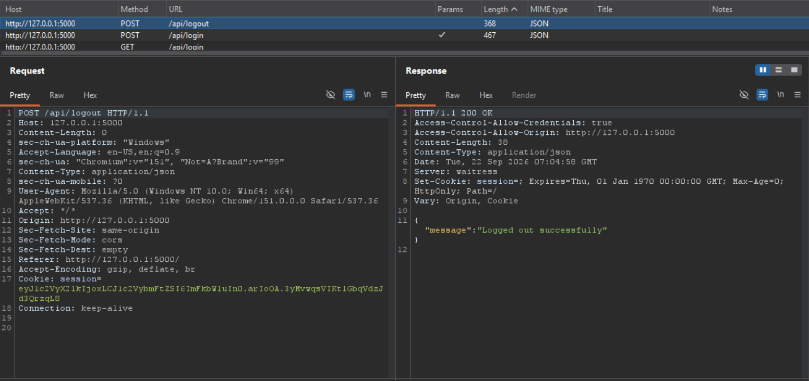

Step 3: Login as User 2
Log in using valid credentials for User 2.
Capture the new authenticated session cookie.
Screenshot 2 – User 2 session 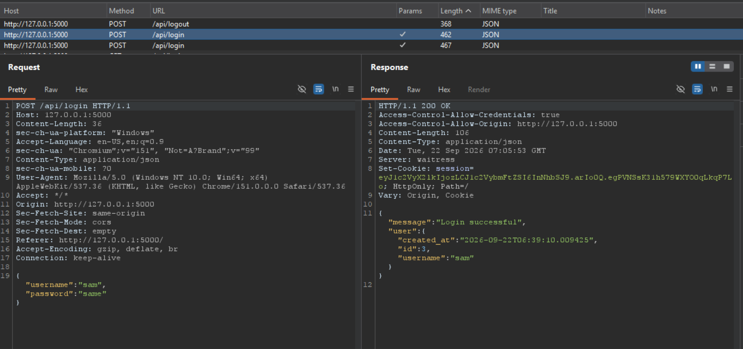
User 2
Username: sam
Session Cookie: <USER_2_SESSION_COOKIE_REDACTED>
The application successfully authenticates User 2 and establishes a separate session.

Step 4: Replace User 2 Cookie with User 1 Cookie
Using Burp Suite Repeater, modify the authenticated request generated under User 2's session. Replace the current User 2 session cookie with the previously captured User 1 session cookie.
Original: Cookie: <USER_2_SESSION_COOKIE_REDACTED>
Replayed: Cookie: <USER_1_SESSION_COOKIE_REDACTED>
The request containing the previously issued User 1 cookie was accepted even though User 1 had already logged out.
Screenshot 3 – Replayed User 1 cookie
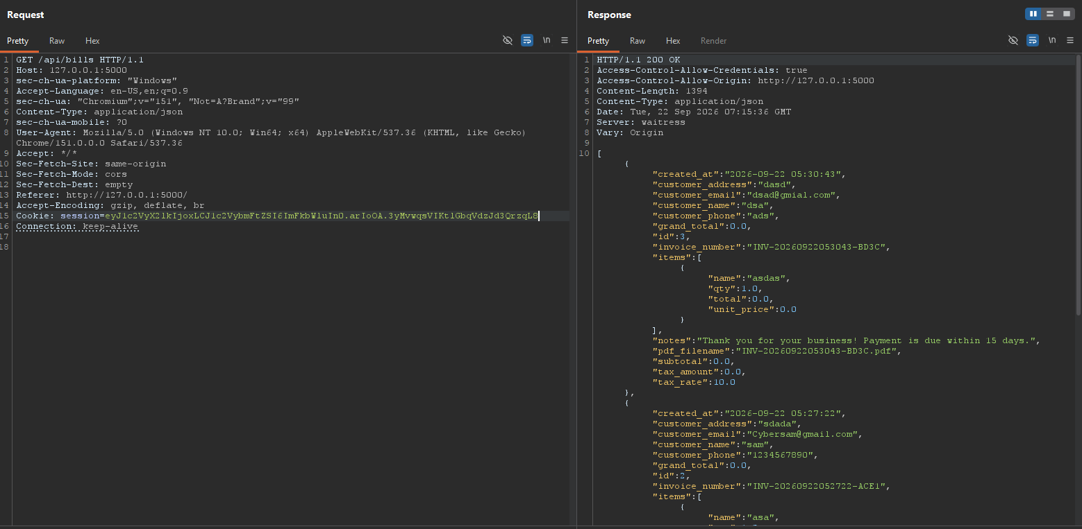
The request containing the previously issued User 1 cookie is accepted by the application even though User 1 has already logged out.

Step 5: Access User 1 Data
Send the modified request to the protected API.
The application returns data associated with User 1 instead of rejecting the request or returning an authentication error.
Screenshot 4 – User 1 data returned
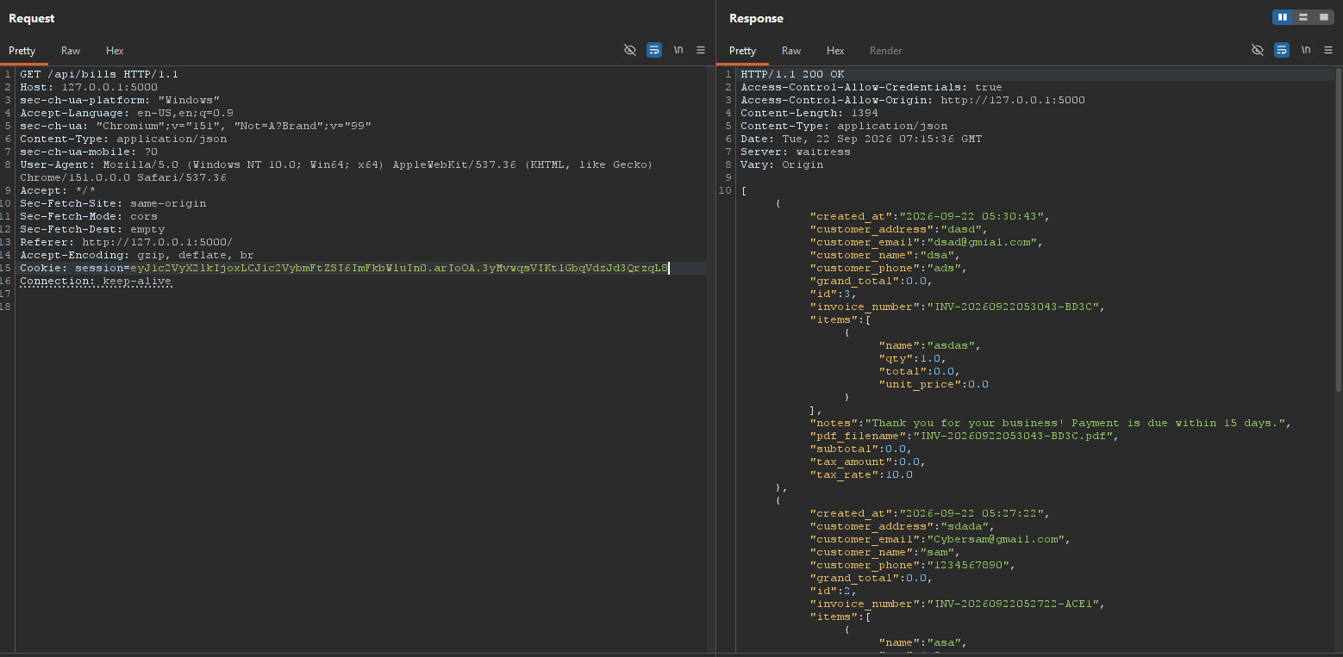
The response demonstrates that the previously issued User 1 session remains valid after logout.

Evidence / Result
The test demonstrated the following sequence:
- User 1 Login
- User 1 Session Cookie Obtained
- User 1 Logout
- User 2 Login
- Replace User 2 Cookie with Old User 1 Cookie
- Protected API Request
- User 1 Data Returned
Result: The application continued to recognize the previously issued User 1 session after logout and allowed access to User 1's authenticated resources.
Recommendation
The application should properly invalidate authenticated sessions when a user logs out.
Recommended controls:
- Invalidate the server-side session associated with the session cookie during logout.
- Ensure a session identifier cannot be reused after logout.
- Implement server-side session revocation for invalidated sessions.
- Rotate session identifiers after successful authentication.
- Configure appropriate session expiration and idle timeouts.
- Clear the authentication cookie on the client during logout.
- Ensure all protected API endpoints verify the validity of the session before processing requests.
- Test session invalidation consistently across all authenticated APIs.
After logout, replaying the previous session cookie should result in an authentication failure, such as:
HTTP/1.1 401 Unauthorized rather than returning the user's protected data.
References / CWE / OWASP
- CWE-613 – Insufficient Session Expiration
- OWASP Top 10 – A07: Identification and Authentication Failures
- OWASP Top 10 – A01: Broken Access Control (related where authorization controls fail to prevent unauthorized access)
Evidence Handling Note
Session cookies are security-sensitive authentication artifacts. The report text and evidence labels have been redacted to avoid unnecessarily disclosing reusable session values. The original screenshots should also be redacted before sharing the report outside the authorized testing environment.

